# 

# Technology Publisher Setup and Data Input





## Contents

Technology Publisher – Nouvant New User Guide 1

What is Technology Publisher? 2

Who is Nouvant? 2

Create Your Technology Publisher Site in Inteum C/S 3

Setup / System Settings / Technology Publisher 3

System Setting steps: 3

Site Settings and Theme in Technology Publisher Admin 4

Admin Home Page 5

1. Site Settings 6

Basic Technology Page (preview) 7

2. Site Theme/Site Templates 8

Inteum Technology Publisher to Nouvant Portfolio Workflow 9

Introduction 9

Contents 1

Nouvant-Inteum Technology Marketing Web Page 10

Inteum Data Fields in the Technology Record 11

Technology Publisher Setup — Categories and Patents 12

Categories and Interests 12

Create Categories or a new a Category 12

Create Interests 12

Patents 13

Allow Patent Types to be uploaded to Technology Publisher 13

Non-Confidential Summary (NCS) Data Input Process 15

Markdown-to-HTML input (recommended) 15

Add an image to an NCS 17

Alternative Title (recommended) 17

Apply a Category or Categories to a Technology 17

Upload a Patent to Technology Publisher and Nouvant Portfolio 19

Markdown Guide and Template 20

What is Markdown? 20

Common Nouvant-used markdown codes 20

Markdown Template 21

Markdown preview 21

This is an h2 header subheading that introduces the paragraph that follows it 22

Applications 22

Advantages 22

Publication 22

Inteum NCS formatting (not recommended) 23

## What is Technology Publisher?

Technology Publisher allows Inteum users to easily publish and market their available technologies on a branded, organization-specific website. Connected to your main technology transfer site, Technology Publisher allows potential leads and licensees to easily search your innovation catalog by category or keyword.

Once your school’s Technology Publisher site is created, you’re just a technology description away (abstract or non-confidential summary) from marketing an innovation online.

Technology Publisher is already included — at no extra cost — in your Inteum system, and the one-time site setup takes less than an hour. With this onboard guide, Nouvant can easily lead you through the process.

## Who is Nouvant?

Nouvant, the industry leader in innovation marketing and IP commercialization, has partnered with Inteum to help its clients “turn on” Technology Publisher and leverage their technology data with this existing tool to market their available intellectual property.

“Turning on” Technology Publisher is also a first, simple step toward utilizing Nouvant’s own technology transfer products: Nouvant Commons DESCRIPTION and Portfolio.

Just log in to Inteum and get started!

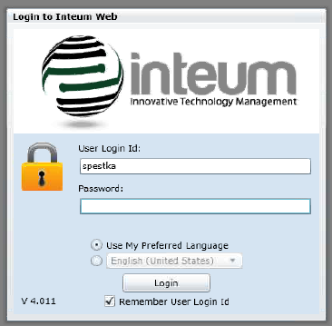

## Create Your Technology Publisher Site in Inteum C/S

The basic Technology Publisher setup should take approximately a half hour. It starts in the Setup tab:

### Setup / System Settings / Technology Publisher

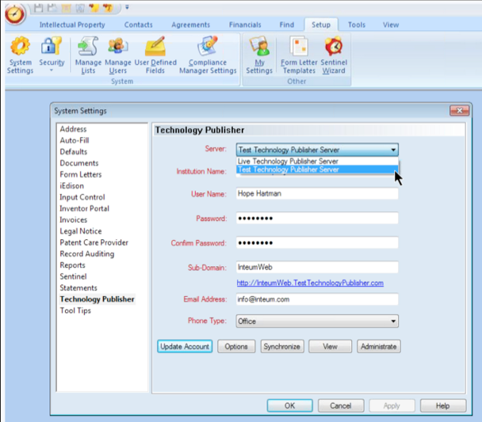

There, you may choose to **create your live Technology Publisher site** (server), or a **test site** for design and testing purposes. Note that, once you are ready to move from a test site to a live site, the setup process will need to be repeated in its entirety.

### System Setting steps:

1. Choose live or test server
2. Enter username and create a password
3. Choose a subdomain. This will be the URL, or Web address, of your Technology Publisher site. Example: *yourname.technologypublisher.com*.
4. Set an email address to receive technology inquiries and other emailed communication.
5. Update, click OK, and you are ready to go to your site admin online!

# Site Settings and Theme in Technology Publisher Admin

Now that your Technology Publisher site exists on a server, your next step is to determine its look and functions in the admin section at:

[YOURNAME].technologypublisher.com/admin *example link*

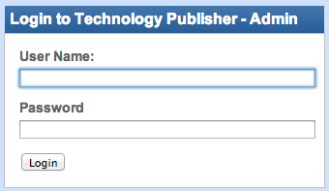

There are just two simple steps required to create a basic Technology Publisher site:

1. Site Settings

2. Choose a theme

This guide will cover that basic setup, with brief descriptions of the additional intermediate and advanced customization options Technology Publisher offers.

### Admin Home Page

The default Home page for your Technology Publisher admin gives some basic site analytics.

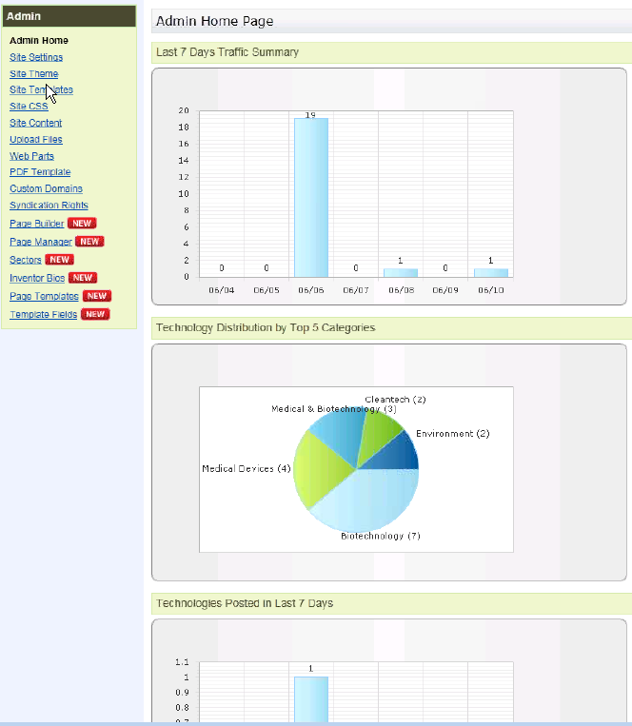

### 1. Site Settings

The Site Settings admin page allows you to upload or manage various elements of your Technology Publisher site:

* organization logo
* link to your organization’s main website
* site analytics tracking codes (such as Google Analytics)
* date format
* information about and links to inventors and researchers
* and more

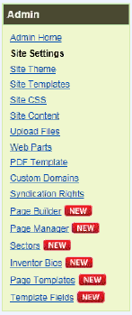

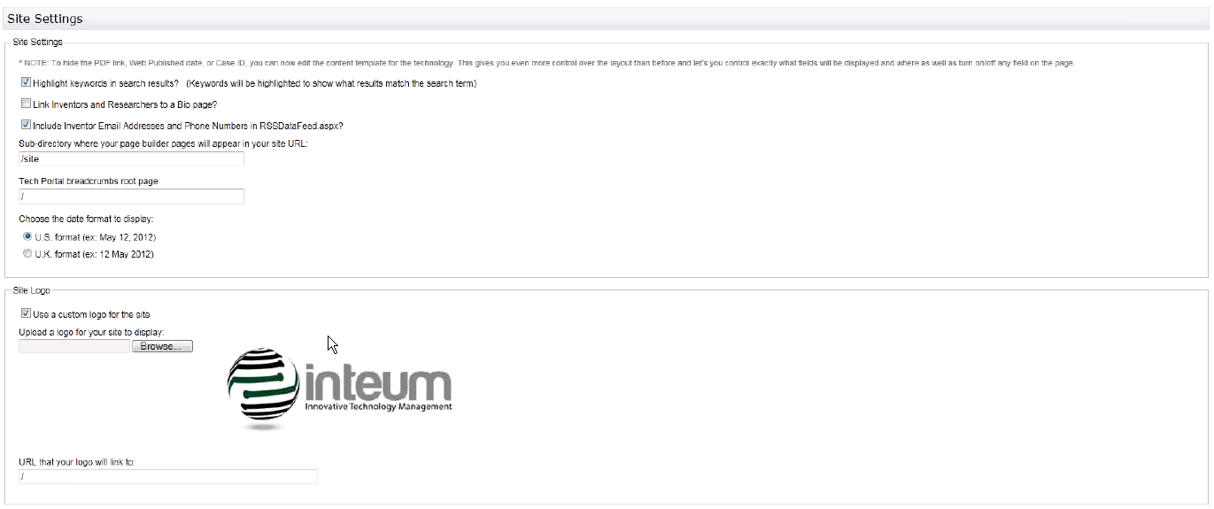

### Basic Technology Page (preview)

Your basic technology page will look something like this:

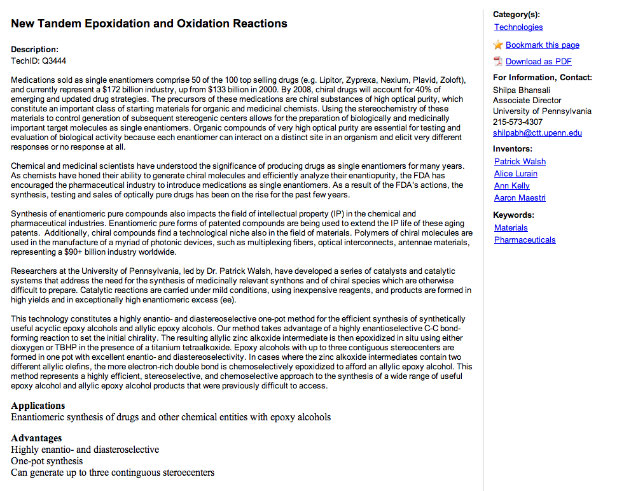

### 2. Site Theme/Site Templates

Choose your site’s color and theme from four supplied templates. Below are views of the landing page, or home page, for each basic template.

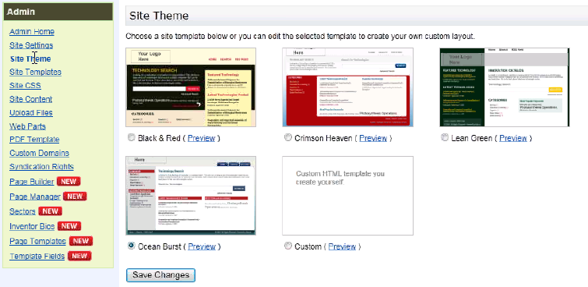

Click preview for a larger view of what your site’s main page will look like.

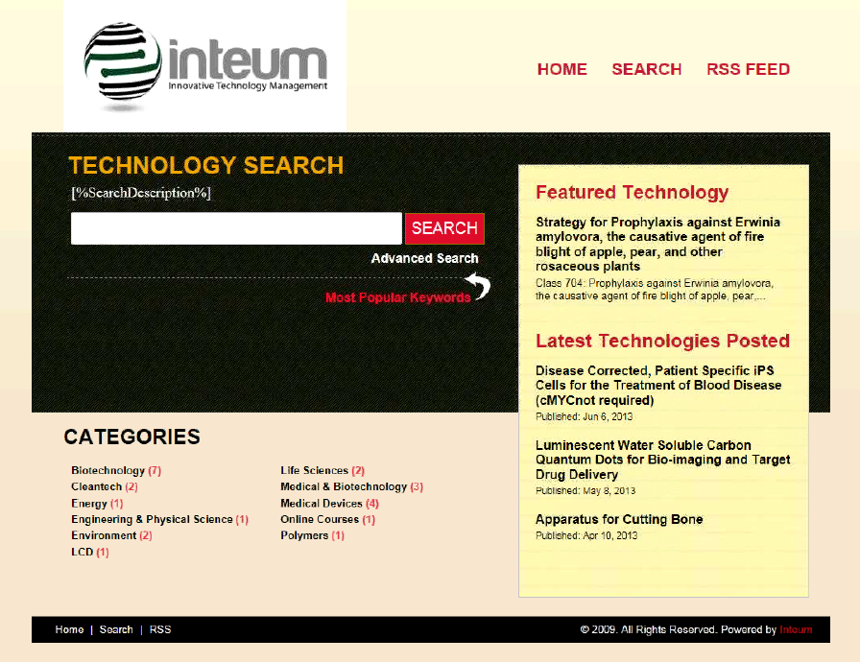

# 

# Inteum Technology Publisher to Nouvant Portfolio Workflow

## Introduction

This workflow guide will help you set up and optimally use your Inteum system and Technology Publisher software to create Technology Marketing Pages on your Nouvant Portfolio website.

Inteum’s Technology Publisher tool “pushes” data to the Nouvant system via RSS feed (Really Simple Syndication), and Nouvant publishes that data with the added benefits of the Nouvant Portfolio Web marketing platform.

The guide outlines two major workflows:

1. One-time set up or cleanup of Categories and Patents
2. Per-technology data input process and non-confidential summary (NCS) creation

We also recommend that you read or review Nouvant’s [Content/SEO Strategy training](http://www.nouvant-university.com/technologies/az-nvnt-1/nouvant-content-and-seo-strategy-arizona), which outlines how to write a compelling and search-engine-optimized abstract with related technology data.

# Nouvant-Inteum Technology Marketing Web Page

The end-goal of this workflow is an Inteum-created Nouvant Portfolio Technology Marketing Web page. The graphic below shows an example page (minus the university-specific branding) with the corresponding Inteum data fields in red.

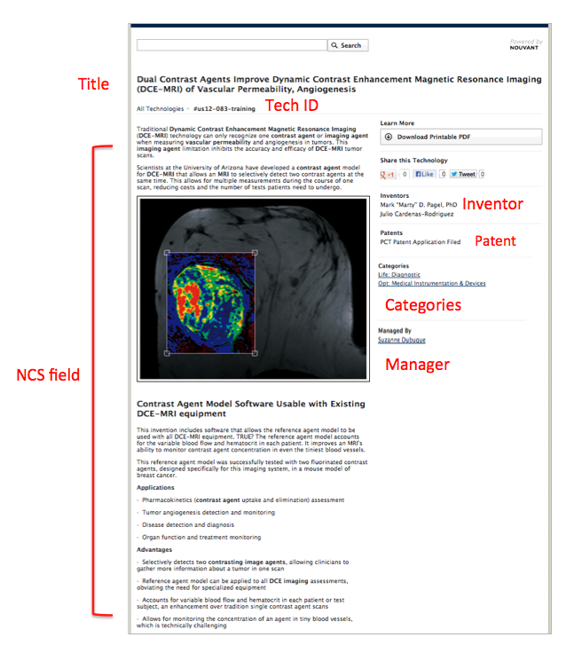

# Inteum Data Fields in the Technology Record

The Inteum data fields that correspond to the fields on a Nouvant Portfolio marketing page reside in the **Technology Record** in the **Utilities** tab.

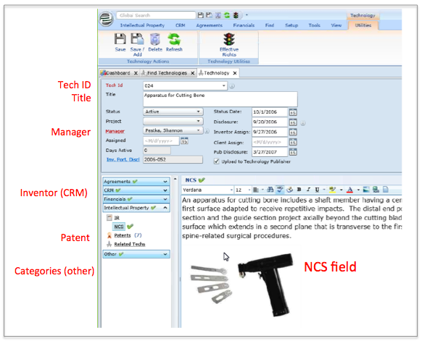

The primary Technology Record view shows:

* Tech ID (SKU)
* Title
* Manager
* Non-Confidential Summary (NCS)

Click to view:

* Inventor (CRM)
* Patent
* Categories and Interests (other)

# Technology Publisher Setup — Categories and Patents

These one-time or occasional categories and patents setup steps will ensure that you are using your Technology Publisher/Nouvant Portfolio connection to its fullest extent.

## Categories and Interests

Inteum-created technology pages can be classified under one or more categories, which are a major navigation tool for Portfolio site visitors.

Technology pages may also include **interests,** which are keywords associated with the technology. While keywords are secondary to category navigation, they help facilitate site search and internal reference.

This section describes how to initially setup your categories or add a new category. The steps for applying categories to a specific technology are outlined later in the data input section.

### Create Categories or a new a Category

In Inteum C/S:

**Setup/Managed Lists/Categories**

Input the top-level category as such:

Physical Sciences and Engineering

You may also create second-, third- or further-level subcategories (although usually not more than two or three levels) by creating another, separate category listing with this *exact* formatting using "hyphen greater than" **->**

Physical Sciences and Engineering->Advanced Materials

Physical Sciences and Engineering->Advanced Materials->Polymers

On your Technology Publisher site, this format will list the top-level and subcategories together on the main page, but no categories on subcategory pages or other pages.

On a Nouvant Portfolio site, this format will list only the top-level category on the main “All Technologies” page, the next-level subcategories on that category’s page, and so on through the levels of categories.

### Create Interests

**Setup/Managed Lists/Interests**

Interests are created and applied the same way as categories.

## Patents

If properly set up and managed, Nouvant Portfolio will automatically create a USPTO patent link or status on the right sidebar of a technology marketing page.

Before you can publish patents on technology pages, however, you must *allow certain types of patents* to be uploaded to Technology Publisher. This one-time setup is described below.

Note: designating a type of patent for upload does not automatically make all patents of that type public. Each patent also needs to be uploaded individually as part of the individual technology record process.

### Allow Patent Types to be uploaded to Technology Publisher

To allow certain patent types to be uploaded to Technology Publisher, access via Inteum C/S:

**Setup/Managed Lists/Patent Application Types**

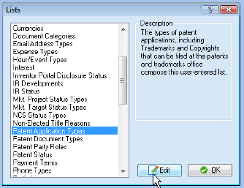

Click “Edit” to open the Patent Application Types list:

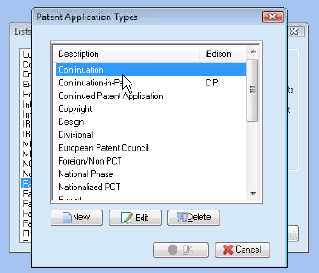

Select the Patent Application Type to be allowed and check “Allow upload to Technology Publisher” in the Patent Application Type window then click “OK.”

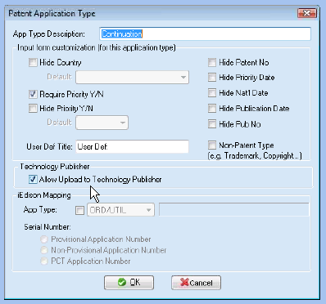

Once a patent type has been allowed for upload, any patent may be included on a Technology Publisher or Nouvant Portfolio site by simply checking a button in the patent record, which can be accessed through the Technology record as part of the NCS process (described later).

# Non-Confidential Summary (NCS) Data Input Process

The **NCS Field** holds most of the Technology Marketing Page data, including:

* Marketing Abstract (paragraphs and headings)
* Applications and Advantages (paragraphs and headings)
* Images
* Web links
* Publications
* Any other relevant information except manager, inventor, patents and categories

There are two ways to input and format the NCS content:

1. Markdown to HTML coding (recommended)
2. Inteum NCS editor input

The first method, outlined below, is a simple workflow addition that will produce well-formatted and search-engine-optimized code for display on your Nouvant Portfolio site.

The second method may be used for less-optimal formatting and is outlined at the end of this document.

Note: the full data input workflow is a combination of the two options. Images, for example, are added to the NCS field using the native Inteum NCS editor tool.

## Markdown-to-HTML input (recommended)

To optimally format your Nouvant technology page for search engines and Web display, use this simple workflow step:

1. Create a text document with Markdown code (see template and guide below)
2. Copy and paste coded text into Markdown-to-HTML converter: <http://daringfireball.net/projects/markdown/dingus>
3. Filter both “Markdown” and Smarty Pants” (dropdown beneath Markdown Source box)
4. Click “Convert”

Two lower fields will appear:

1. HTML Source – this is the HTML code you will copy and paste into the Inteum NCS HTML-view window.
2. HTML Preview – Before you copy and paste the HTML, preview and test your code in the third window down. Click on links to confirm they work and lead to where you intended.

Once you have confirmed that your markdown and resulting HTML are correct, copy and paste it into the NCS HTML view by clicking the last icon on the NCS toolbar:

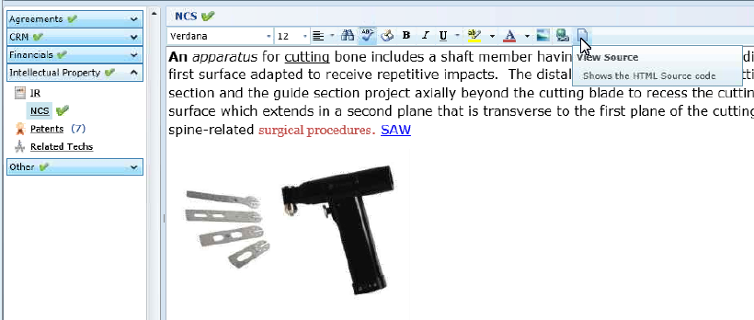

Replace all existing text with the converted HTML code, click save, and your new NCS should appear in the main NCS field.

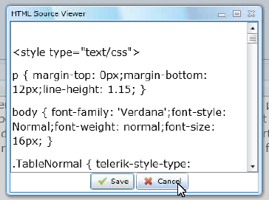

## Add an image to an NCS

To embed an image to your NCS content, you may use the Inteum NCS editor. Simply place your cursor at the location you wish to add the image and click the “Picture” button in the toolbar:

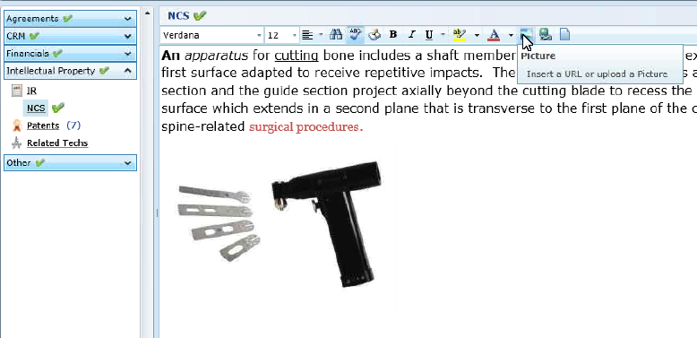

Select the image to be uploaded. You may type a caption above or below the image using the main NCS editor view.

## Alternative Title (recommended)

The box on the far right of the Technology Record view allows you to give that technology an **Alternative Title,** which will be used as the title of your technology on the Nouvant Portfolio page. If no Alternative Title is present, the technology Web title will be taken from the main title field, which may be less Web-appropriate or search engine optimized. Nouvant recommends this practice.

## Apply a Category or Categories to a Technology

From the Technology Record, you can select a category or categories to be applied to that particular technology.

**Utilities/Technology/Other/Categories**

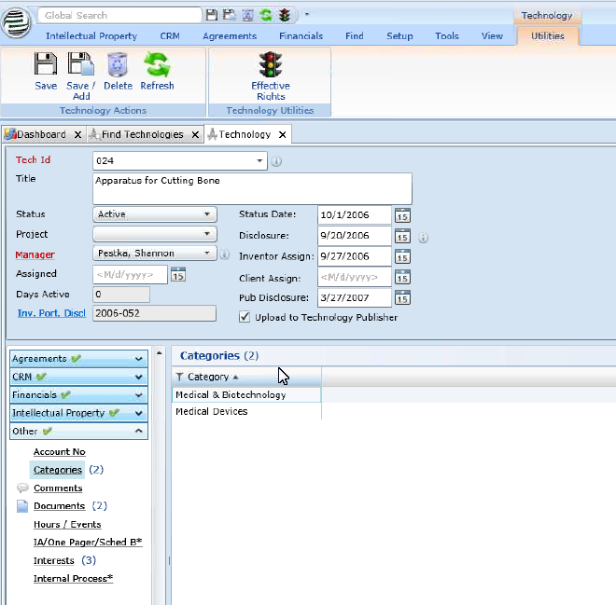

Right-click to apply a category from the list. You may also create a new category, following the earlier instructions, and then apply it to the technology.

## Upload a Patent to Technology Publisher and Nouvant Portfolio

Once a patent type has been allowed for upload, any patent may be included on a Technology Publisher or Nouvant Portfolio site by simply checking a button in the patent record, which can be accessed through the Technology Record as part of the NCS process:

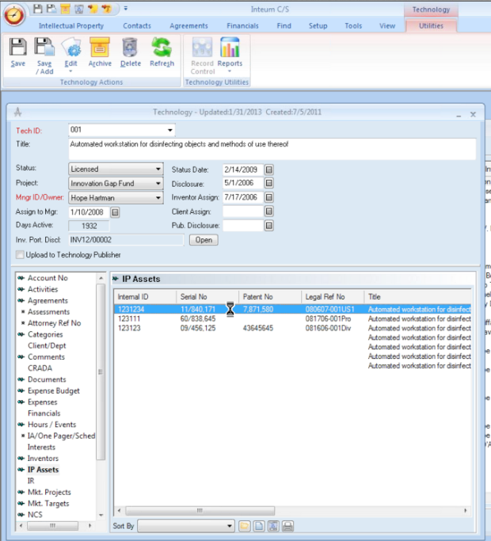

Click to open the patent to be displayed, and check “Upload to Technology Publisher.”

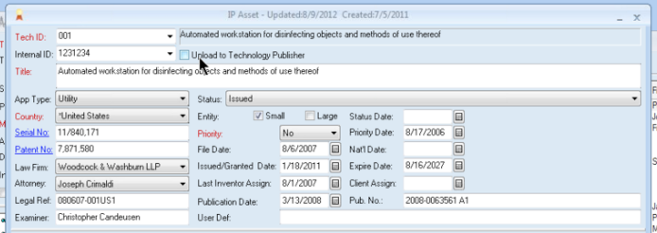

# Markdown Guide and Template

## What is Markdown?

Markdown is HTML shortcut code that allows you to easily format Web content using simple code elements. Nouvant Portfolio technology marketing abstracts use only a couple of key format elements, mainly h2 headers, bulleted lists, and Web links. These simple workflow steps will produce well-formatted SEO content, and we strongly recommend it.

The coding for each is shown below, with an example abstract you may use as a template for your own NCS content creation.

## Common Nouvant-used markdown codes

**##[space]** = h2 header (subheading)

**\*[space]** = bullet item in unordered list

**1.[space]** = numbered item in ordered list

**[Link Text](http://linkURL.com)** will create the link: [Link Text](http://example.com/) *(Note: no spaces in this formula)*

**[Link Text](http://linkURL.com**"**Hover Text**"**)** will create the link: [Link Text](http://example.com/) and the words “Hover Text” will appear when you mouse over the link.

Note: more markdown codes can be found on the [Daring Fireball “Dingus” markdown-to-HTML converter](http://daringfireball.net/projects/markdown/dingus).

# Markdown Template

This template is a reference guide and working tool for creating an optimally formatted marketing abstract or NCS. Save this document under a new, technology-specific file name, then ***replace the content in green with new abstract content.***

**Notes:**

* Do not include the Title of the technology. It comes from a separate field.
* Two Web link options are offered: with and without a “title” attribute (hover/caption text)
* Curly quotes: html will **not** recognize “curly quotes” like the ones in this sentence. The publication link in this template uses straight quotes, and so should you, or your links will not work. (You can replace them after pasting your copy into the Dingus editor.)
* More markdown code details are available at: <http://daringfireball.net/projects/markdown/dingus>
* You may input and convert a combination of HTML and markdown, such as to embed a video (see html in template example)

Paragraph-style text needs no markdown formatting. Just type the paragraph as desired for the main content of your abstract or non-confidential summary. Replace this sample content (in green) with the desired content per technology. Note that there is no Title before this paragraph; the Title comes from an existing field.

## This is an h2 header subheading that introduces the paragraph that follows it

This is the paragraph that follows the above subheading, again with no formatting. To include two paragraphs separated by a line break, simply hit return twice and begin typing your next paragraph.

Like this sample text to make this paragraph long enough to include an automatic line break to be a good example of paragraph text.

## Applications

* Applications above is a subheading

* Each asterisk-space line will be included in a bulleted list

* In html terms, this is called an unordered list

## Advantages

* Advantages above is a subheading

* This list is formatted the same as " Applications" above

## Publication

[Article Name or other information that will become the link text](http://URL address to be linked to "Article Name that will appear when you hover over the link"]

**(Embedded Video example)**

<iframe width="640" height="360" src="http://www.youtube.com/embed/6Xj8dTegqDw?feature=player_embedded" frameborder="0" allowfullscreen></iframe>

## 

## Markdown preview

This is what the above markdown coding will produce online once it is converted to HTML:

Paragraph-style text needs no markdown formatting. Just type the paragraph as desired for the main content of your abstract or non-confidential summary. Replace this sample content (in green) with the desired content per technology. Note that there is no Title before this paragraph; the Title comes from an existing field.

## This is an h2 header subheading that introduces the paragraph that follows it

This is the paragraph that follows the above subheading, again with no formatting. To include two paragraphs separated by a line break, simply hit return twice and begin typing your next paragraph.

Like this sample text to make this paragraph long enough to include an automatic line break to be a good example of paragraph text.

## Applications

* Applications above is a subheading
* Each asterisk-space line will be included in a bulleted list
* In html terms, this is called an unordered list

## Advantages

* Advantages above is a subheading
* This list is formatted the same as the above applications

## Publication

Article Name or other information as link

# Inteum NCS formatting (not recommended)

You may use the existing Inteum content editor to input and format your NCS, *however, it may result in less-than-optimal display and search engine optimization on the Nouvant platform*. For optimal formatting and display, use the markdown guidance and template outlined above.

To Access the **NCS field:**

1. In “**Utilities” tab,** under “**Technology” view,** expand the **“intellectual property” tab** on the left, then check “**NCS**.”
2. Type or Paste your abstract content into the editor field, using the formatting bar to style and add elements like images and Web links. **Important**: do not paste formatted Word document text into the editor; it will cause problems. Paste unformatted text and format using the NCS field toolbar.
3. The last icon in the formatting bar allows you to view and edit the NCS as HTML code; you can switch to this mode to code-fix formatting snafus or to add elements not supported in the toolbar (like embed YouTube video).
4. The box on the far right of the Technology Record view allows you to add the technology to your **“Featured Technologies” list**, see the technology’s status, and give it an **Alternative Title,** which will be used as the title of your technology instead of the main title field. (This is to provide a more Web-appropriate title without disrupting established record data.)
5. When you are ready to publish the technology page on the Web, the last step is always to check the **“Upload to Technology Publisher”** button just above the NCS field.